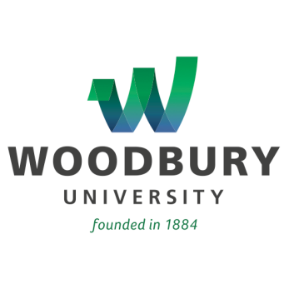

Media Advisory
In Association with CEO Magazine, State Treasurer John Chiang to Speak at Woodbury University on March 12th

State Official to Appear as Part of Baron Business Plan Lecture Series

LOS ANGELES, Calif. (March 5, 2015) – Recently elected California state treasurer
John Chiang will speak at Woodbury University on Thursday, March 12th, as part of the university’s Baron Business Plan Lecture Series. Cosponsoring the event with the university is CEO Magazine.

Chiang has a reputation for vigorously restoring public trust through reform. He served as State Controller from 2007 to 2015, and was a member of the State Board of Equalization from 1998 to 2006. A January 2013 article in Governing named him as one of the top state Democratic officials to watch in 2013. Prior to elective office, he was an attorney in the California controller's office and a tax law specialist with the IRS. Chiang was born in New York City to Taiwanese immigrants. He holds a B.A. in finance from the University of South Florida and a law degree from Georgetown University.

Who: John Chiang, California State Treasurer

When: Thursday, March 12, from 6 p.m. to 7:30 p.m.

Where: Fletcher Jones Foundation Auditorium, Woodbury University campus,
7500 N. Glenoaks Blvd., Burbank

RSVP: CEO@woodburyuniversity.edu, by March 9

About Woodbury University
Founded in 1884, Woodbury University is one of the oldest institutions of higher education in Southern California. Woodbury offers bachelor's degrees from the School of Architecture, School of Business, School of Media, Culture & Design, and College of Transdisciplinarity, along with a Master of Arts (MA) in Media for Social Justice, Master of Architecture (MArch), Master of Interior Architecture (MIA), Master of Science in Architecture (MSArch), and Master of Leadership. The San Diego campus offers Bachelor of Architecture and Master of Architecture degrees, as well as an MSArch degree with concentrations in Real Estate Development and Landscape + Urbanism. Woodbury ranks 15th among the nation’s “25 Colleges That Add the Most Value,” according to Money Magazine. Visit www.woodbury.edu for more information.

Media Contact:
Ken Greenberg
Edge Communications, Inc.
(323) 469-3397
ken@edgecommunicationsinc.com

