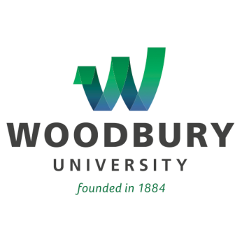

For Immediate Release

Woodbury University Commemorates New Lucas Gate
In Ribbon-Cutting Ceremony

Construction on New Front Entrance Puts Safety First,
Promises to Improve Traffic Flow on Glenoaks

LOS ANGELES (November 17, 2014) – Officials from Woodbury University were recently joined by benefactor Dorothy Z. Doyle for a ribbon-cutting ceremony commemorating the start of construction on the school's new front gate, dedicated to William Robert Lucas, her late husband and a longtime leader in the Woodbury community.

Construction on the gate is made possible thanks in large part to a $500,000 donation from Ms. Doyle. Her husband, William Robert “Bob” Lucas, graduated from Woodbury in 1952 and served as vice chairman of the university's Board of Trustees, as well as chairman of the finance committee, from 1983 to 2011, where he proved instrumental in Woodbury's move to the Burbank campus. The university awarded him an honorary doctorate in Business Administration in 2010. The Ahmanson Foundation also contributed $750,000 toward the project.

Woodbury President Luis Maria R. Calingo, Ph.D., cited student safety concerns as the impetus for the project, which will also add a traffic light and sidewalk improvements at the intersection of Glenoaks and Cohasset. In order to install the street light, the City of Burbank required that the university move the gate some 30 feet, aligning it with Cohasset.

"The safety of our students and faculty is paramount," said Dr. Calingo. "Controlling traffic at the entrance to our campus will make the university literally and figuratively an even more welcoming place. We deeply appreciate Dorothy Doyle’s generosity and the support of the Ahmanson Foundation."

The Lucas Gate was designed by Louis M. Naidorf, FAIA, Trustee and Dean Emeritus of the School of Architecture, and will be built by S3 Builders Inc., a Southern California construction company that has previously worked with Woodbury, as well as with Cedars-Sinai Medical Center, the Disney/ABC Television Group and Macy's.
About Woodbury University
Founded in 1884, Woodbury University is one of the oldest institutions of higher education in Southern California. Woodbury offers bachelor's degrees from the School of Architecture, School of Business, School of Media, Culture & Design, and College of Transdisciplinarity, along with a Master of Arts (MA) in Media for Social Justice, Master of Architecture (MArch), Master of Interior Architecture (MIA), Master of Science in Architecture (MSArch), and Master of Leadership. The San Diego campus offers Bachelor of Architecture and Master of Architecture degrees, as well as an MSArch degree with concentrations in Real Estate Development and Landscape + Urbanism. Woodbury ranks 15th among the nation’s “25 Colleges That Add the Most Value,” according to Money Magazine. Visit www.woodbury.edu for more information.

Media Contact:
Ken Greenberg
Edge Communications, Inc.
(323) 469-3397
ken@edgecommunicationsinc.com

